1. (10) Given the grammar below, identify which sentences are in the language (which are valid sentence).
   1. baab
   2. bbbab
   3. bbaaaaaa
   4. bbaab

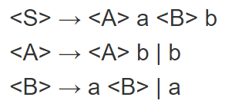

Based on the grammar rules above,

1. **baab**
2. **bbaab**

are valid.

1. (10) Identify all of the tokens (categories of lexemes) in the grammar below, and which lexemes they categorize. Put them in a table.

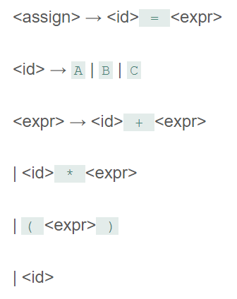

|  |  |
| --- | --- |
| **Token** | **Lexemes** |
| Identifiers | A,B,C |
| Operators | =, +, * |
| Parenthesis | (, ) |

1. (10) Given the grammar from question 2, show a left-most derivation and draw the parse tree for the following statement.
   1. B = B + (C + (A * A) )

<assign> -> <id> = <expr>

-> B = <expr>

-> B = <id> + <expr>

-> B = B + <expr>

-> B = B + (<expr>)

-> B = B + (<id> + <expr>)

-> B = B + (C + <expr>)

-> B = B + (C + (<expr>))

-> B = B + (C + (<id> * <expr>))

-> B = B + (C + (A * <expr>))

-> B = B + (C + (A * <id>))

-> B = B + (C + (A * A))

Parse Tree:

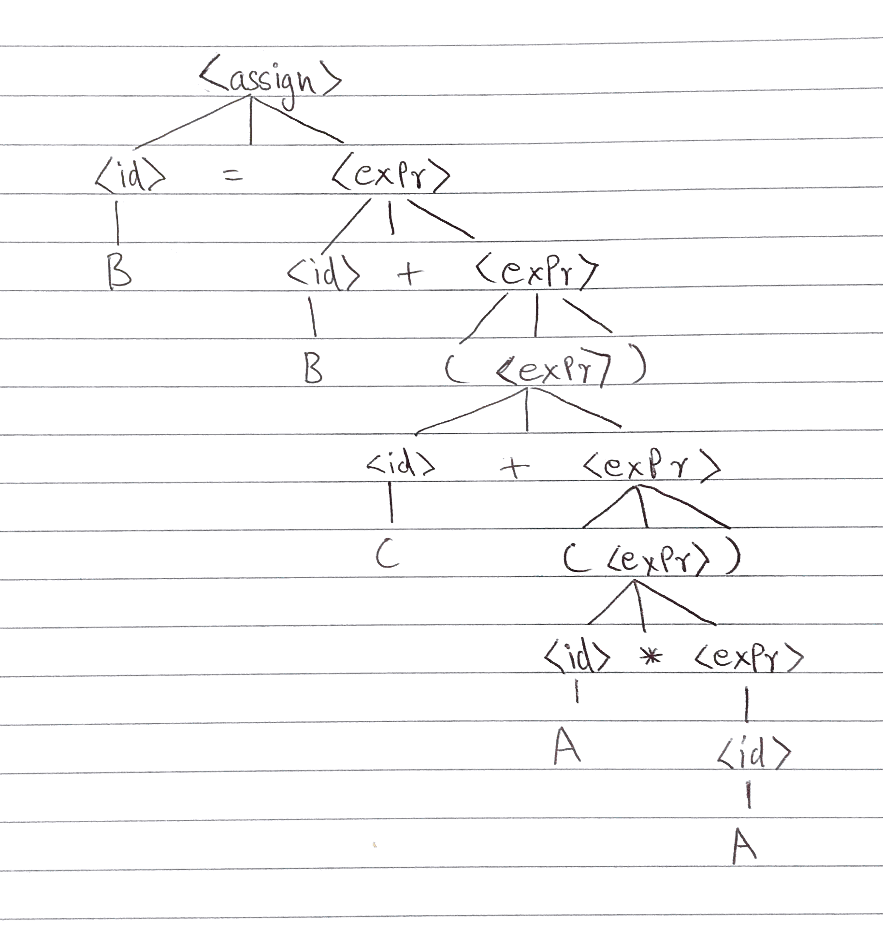

1. (10) Remove all of the recursion from the following grammar:

S -> Aa | Bb

A -> Aa | AbC | C

B -> S | bb

C -> c

S -> Aa | Bb

A -> CA’

A’ -> aA’ | bCA’ | ε

B -> AaB’ | bbB’

B’ -> bB’ | ε

C -> c

1. (10) Use left factoring to resolve the pairwise disjointness problems in the following grammar:

A -> aBc | ac | a

B -> b | aB

A -> aA’

A’ -> Bc | c | ε

B -> b | aB

1. (20 pts) Create an LR(0) parse table for the following grammar. Show all steps (creating closures, the DFA, the transition table, and finally the parse table):

E -> E + T | E * T | T

T -> ( E ) | id

r0: S’ -> E$

r1: E -> E + T

r2: E -> E * T

r3: E -> T

r4: T -> ( E )

Transition Table:

|  |  |  |  |  |  |  |  |
| --- | --- | --- | --- | --- | --- | --- | --- |
|  | T | ( | E | Id | + | * | ) |
| S0 | S1 | S4 | S2 | S3 |  |  |  |
| S1 |  |  |  |  |  |  |  |
| S2 |  |  |  |  | S7 | S9 |  |
| S3 |  |  |  |  |  |  |  |
| S4 | S1 | S4 | S5 | S3 |  |  |  |
| S5 |  |  |  |  | S7 | S9 | S6 |
| S6 |  |  |  |  |  |  |  |
| S7 | S8 |  |  | S3 |  |  |  |
| S8 |  |  |  |  |  |  |  |
| S9 | S10 |  |  | S3 |  |  |  |
| S10 |  |  |  |  |  |  |  |

Parse Table:

|  |  |  |  |  |  |  |  |  |
| --- | --- | --- | --- | --- | --- | --- | --- | --- |
| States | Action | | | | | Go To | | |
|  | ( | + | * | ) | $ | E | T | id |
| S0 | S4 |  |  |  |  | S2 | S1 | S3 |
| S1 | R3 | R3 | R3 | R3 | R3 |  |  |  |
| S2 |  | S7 | S9 |  | accept |  |  |  |
| S3 | R5 | R5 | R5 | R5 | R5 |  |  |  |
| S4 | S4 |  |  |  |  | S5 | S1 | S3 |
| S5 |  | S7 | S9 | S6 |  |  |  |  |
| S6 | R4 | R4 | R4 | R4 | R4 |  |  |  |
| S7 |  |  |  |  |  |  | S8 | S3 |
| S8 | R1 | R1 | R1 | R1 | R1 |  |  |  |
| S9 |  |  |  |  |  |  | S10 | S3 |
| S10 | R2 | R2 | R2 | R2 | R2 |  |  |  |

1. (20 pts) Show a complete bottom-up parse, including the parse stack contents, input string, and action for the string below using the parse table you created in step 6. Think about how I went through this in class.

(id + id) * id

Step 1:

Input: .(id + id) * id

Stack: 0

Output:

Step 2:

Input: (.id + id) * id

Stack: 0 ( 4

Output:

Step 3:

Input: ( id. + id) * id

Stack: 0 ( 4 id 3

Output:

Step 4:

Input: ( id. + id) * id

Stack: 0 ( 4 T 1

Output: R5

Step 5:

Input: ( id. + id) * id

Stack: 0 ( 4 E

Output: R5, R3

Step 6:

Input: ( id. + id) * id

Stack: 0 ( 4 E 5

Output: R5, R3

Step 7:

Input: ( id +. id) * id

Stack : 0 ( 4 E 5 + 7

Output: R5, R3

Step 8:

Input: ( id + id.) * id

Stack : 0 ( 4 E 5 + 7 id 3

Output: R5, R3

Step 9:

Input: ( id + id.) * id

Stack : 0 ( 4 E 5 + 7 T

Output: R5, R3, R5

Step 10:

Input: ( id + id.) * id

Stack : 0 ( 4 E

Output: R5, R3, R5, R1

Step 11:

Input : ( id + id.) * id

Stack : 0 ( 4 E 5

Output: R5, R3, R5, R1

Step 12:

Input: ( id + id). * id

Stack : 0 ( 4 E 5 ) 6

Output: R5, R3, R5, R1

Step 13:

Input: ( id + id). * id

Stack : 0 T 1

Output: R5, R3, R5, R1, R4

Step 14:

Input : ( id + id). * id

Stack: 0 E 2

Output: R5, R3, R5, R1, R4, R3

Step 15:

Input: ( id + id) *. Id

Stack: 0 E 2 * 9

Output: R5, R3, R5, R1, R4, R3

Step 16:

Input: ( id + id) * id.

Stack: 0 E 2 * 9 id 3

Output : R5, R3, R5, R1, R4, R3

Step 17:

Input: ( id + id) * id.

Stack: 0 E 2 * 9 T

Output : R5, R3, R5, R1, R4, R3, R5

Step 18:

Input: ( id + id) * id.

Stack: 0 E 2 * 9 T 10

Output : R5, R3, R5, R1, R4, R3, R5

Step 19:

Input: ( id + id) * id.

Stack: 0 E

Output : R5, R3, R5, R1, R4, R3, R5, R2

1. (10 pts) Show a rightmost derivation for the string above, and show how the bottom-up parse you completed in step 7 correctly finds all of the handles for the input string above.

r0: S’ -> E$

r1: E -> E + T

r2: E -> E * T

r3: E -> T

r4: T -> ( E )

r5: T -> id

(id + id) * id

Output: R5, R3, R5, R1, R4, R3, R5, R2

1. E

2. E * T (2)

3. E * id (5)

4. T * id (3)

5. ( E ) * id (4)

6. ( E + T) * id (1)

7. ( E + id) * id (5)

8. ( T + id) * id (3)

9. ( id + id) * id (5)